SliceWise — Product Roadmap
FOR EXAMPLE PURPOSES ONLY. This roadmap is for a sample research and development project (SliceWise) with a human-subjects study. Each team should review and assess it for applicability, build its own from its own backlog and velocity, and consider items this example does not include. Examples: your IRB's actual review cycle (some boards meet monthly); exam weeks and breaks when participants are unavailable; GPU maintenance windows; a paper or poster submission deadline; a showcase date; and time for a protocol amendment if the pilot changes the tasks.
SliceWise is delivered in three releases over 25 weeks (two semesters) — the impact engine with first accuracy results (RQ1) in week 13, the VS Code tool with grounded explanations and a frozen study protocol in week 19, and the user-study results with a replication package in week 25. Two research gates have no slack: IRB submission in week 6 and the one-time locked test run in week 18.

At a glance
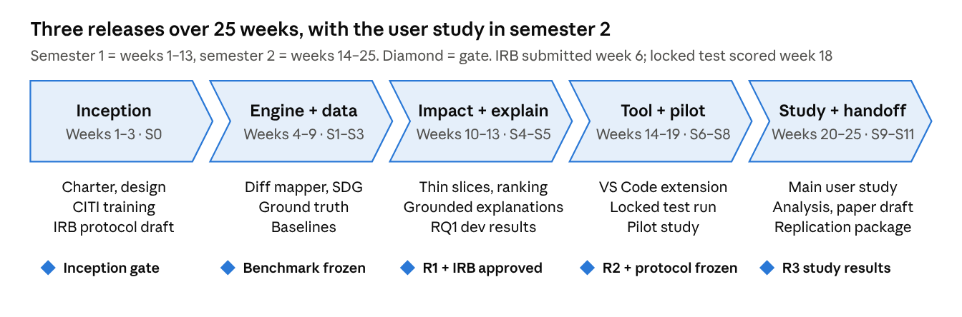
Image 1: roadmap · 5 phases, 5 gates

Semester 1 is research infrastructure: a benchmark with trustworthy ground truth, a slicing engine, and an honest comparison against baselines. Semester 2 puts the engine in developers' hands and tests it with people.

Schedule
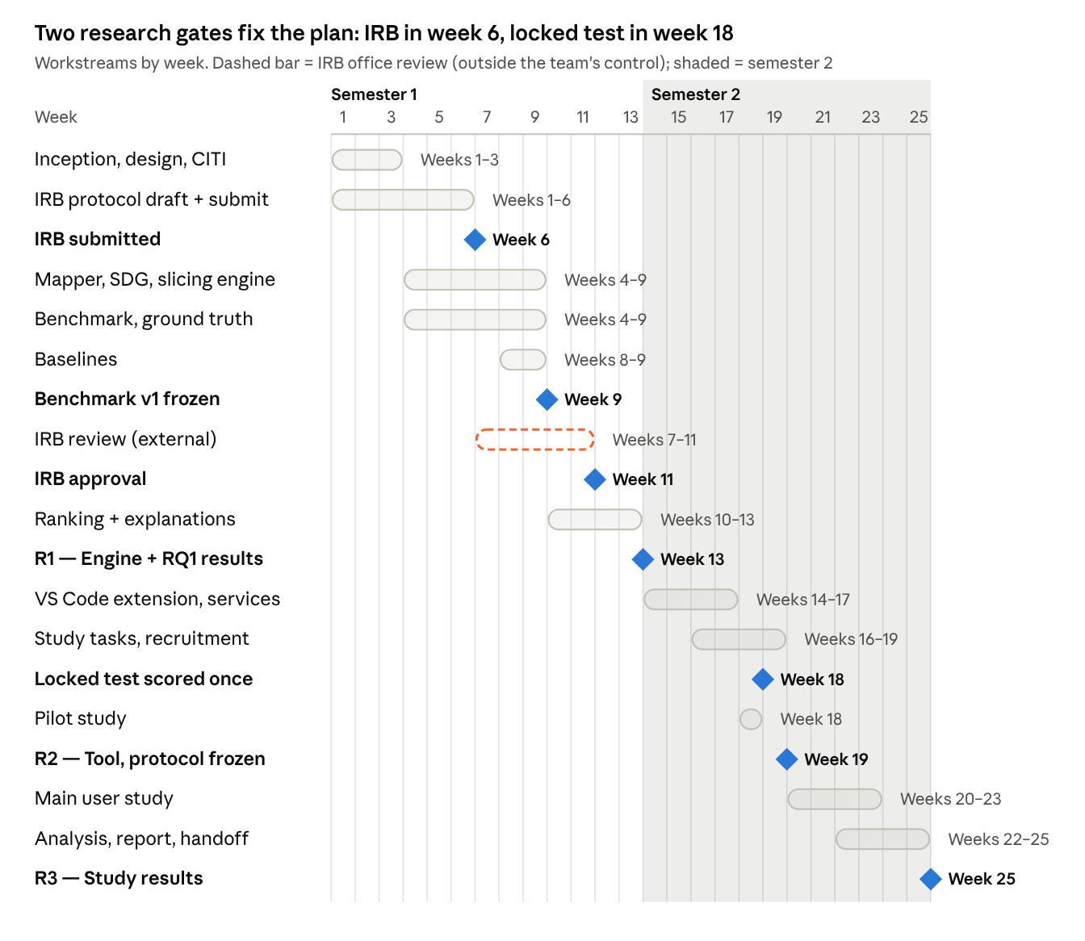
Image 2: Gantt · SliceWise workstreams, IRB review and gates
The IRB review runs in parallel with engine work, so a slow review delays only the study, not RQ1. The pilot sits in week 18 so any protocol amendment can be filed before the main study starts in week 20.

Research and study gates
Week | Gate | Must be true to pass | Owner
3 | Inception complete | Charter, working agreement, design and study outline reviewed by PO and mentor; CITI training done by all; subject projects shortlisted | Scrum Master
6 | IRB protocol submitted | Protocol, consent form, recruitment text and task materials reviewed by mentor and submitted | Study lead
9 | Benchmark v1 frozen | Changes selected; ground truth built; annotation kappa ≥ 0.7; development and locked test splits stored, locked split sealed | Research lead
11 | IRB approval | Approval letter received (fallback: shortened study plan activated) | Study lead
18 | Locked test scored | Engine frozen at a tagged commit; locked split run once; results logged in MLflow | Research lead
18 | Pilot complete | [3–4] pilot sessions; task timing and difficulty checked; protocol changes filed as an amendment if needed | Study lead
20–23 | Main study | Sessions run as approved; target n ≥ [20] | Study lead

Releases
Release | Week | What the client gets | Accepted when
R1 — Impact engine v1 and RQ1 results | 13 (end of semester 1) | Slicing engine (full and thin forward slices); change mapper; ranking; four baselines; benchmark v1; RQ1 results on the development split; first grounded explanations | Engine passes hand-checked slice tests; dev-split results logged and reproducible; IRB approved or fallback agreed
R2 — SliceWise tool and frozen protocol | 19 | VS Code extension (highlights, impact panel, propagation view, explanations); services on department servers; locked-test RQ1 results; pilot findings; frozen study protocol | PO demo on two unseen changes; grounding ≥ [95%] on dev split; pilot ran without tool blockers
R3 — Study results and handoff | 25 | RQ2 and RQ3 results; final report and paper draft; replication package; runbook and handoff | Charter success criteria met or explained; a non-author reruns RQ1 tables from the replication package

Using this roadmap at instructor meetings
- Show the chevron diagram and mark the current phase.
- Report the next gate as On track, At risk or Late, with one line on why.
- Add one line on the IRB status until approval arrives, then on study recruitment (sign-ups vs target).
- Keep the client's detailed bi-weekly schedule in GitLab, not on this page.

Key dependencies
- Research mentor available as IRB principal investigator — confirmed at the Sprint 0 review.
- GPU server access and a language-model license decision — by week 5.
- OpenStack VM and GitLab project from department IT — by week 4.
- A lab room for study sessions in weeks 18–23 — booked by week 12.
- Participants from upper-level SE courses — recruitment opens week 16, with instructors' permission to announce.

